**IT 230 Final Project Part I**

**IT-230 Software Development With C#**

**Tatiana Epps**

**February 9, 2025**

**Final Project Part I**

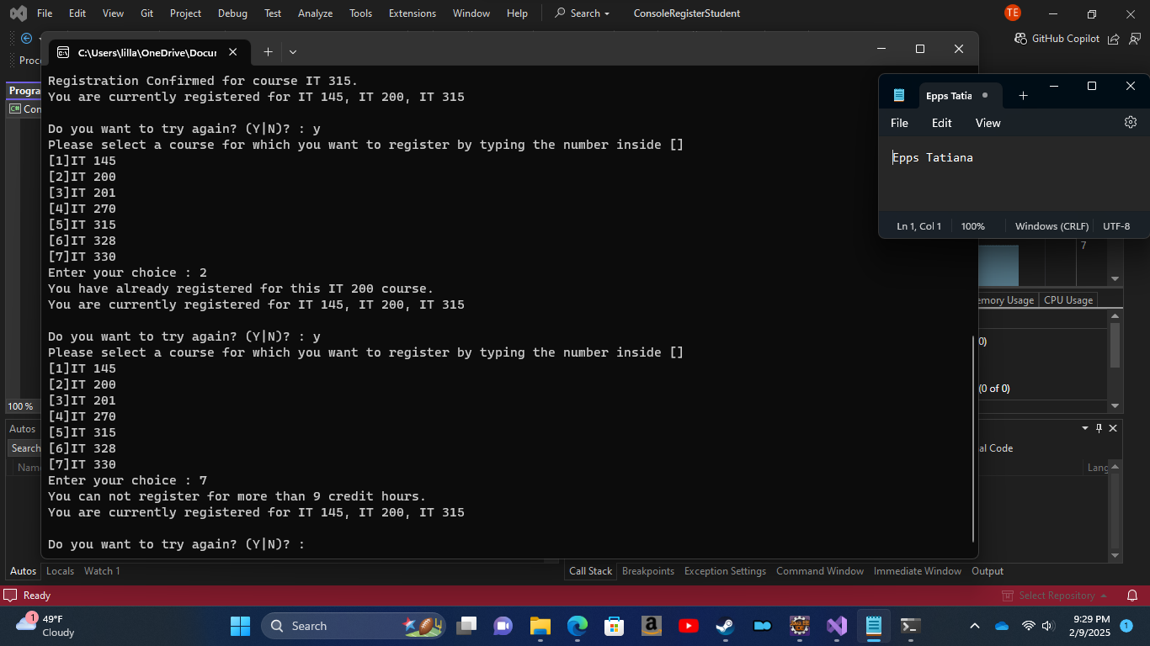

**using System;**

**using System.Collections.Generic;**

**using System.Linq;**

**using System.Text;**

**using System.Threading.Tasks;**

**namespace ConsoleRegisterStudent**

**{**

**class Program**

**{**

**static void Main(string[] args)**

**{**

**(new Program()).run();**

**}**

**void run()**

**{**

**int choice;**

**int firstChoice = 0, secondChoice = 0, thirdChoice = 0;**

**int totalCredit = 0;**

**string yesOrNo = "";**

**//Opening Line**

**System.Console.WriteLine("Teacher's Copy");**

**//Choice Loop**

**do**

**{**

**WritePrompt();**

**choice = Convert.ToInt32(Console.ReadLine());**

**switch (ValidateChoice(choice, firstChoice, secondChoice, thirdChoice, totalCredit))**

**{**

**case -1:**

**Console.WriteLine("Your entered selection {0} is not a recognized course.", choice);**

**break;**

**case -2:**

**Console.WriteLine("You have already registered for this {0} course.", ChoiceToCourse(choice));**

**break;**

**case -3:**

**Console.WriteLine("You can not register for more than 9 credit hours.");**

**break;**

**case 0:**

**Console.WriteLine("Registration Confirmed for course {0}.", ChoiceToCourse(choice));**

**totalCredit += 3;**

**if (firstChoice == 0)**

**firstChoice = choice;**

**else if (secondChoice == 0)**

**secondChoice = choice;**

**else if (thirdChoice == 0)**

**thirdChoice = choice;**

**break;**

**}**

**WriteCurrentRegistration(firstChoice, secondChoice, thirdChoice);**

**Console.Write("\nDo you want to try again? (Y|N)? : ");**

**yesOrNo = (Console.ReadLine()).ToUpper();**

**} while (yesOrNo == "Y");**

**//Final Exit Comment and Choice for User**

**Console.WriteLine("Thank you for registering with us");**

**Console.ReadLine();**

**}**

**//Opening Prompt**

**void WritePrompt()**

**{**

**Console.WriteLine("Please select a course for which you want to register by typing the number inside []");**

**Console.WriteLine("[1]IT 145\n[2]IT 200\n[3]IT 201\n[4]IT 270\n[5]IT 315\n[6]IT 328\n[7]IT 330");**

**Console.Write("Enter your choice : ");**

**}**

**//Selection metrics**

**int ValidateChoice(int choice, int firstChoice, int secondChoice, int thirdChoice, int totalCredit)**

**{**

**if (choice < 1 || choice > 7)**

**return -1;**

**else if (choice == firstChoice || choice == secondChoice || choice == thirdChoice)**

**return -2;**

**else if (totalCredit == 9)**

**return -3;**

**return 0;**

**}**

**//Loop for results shown after registering**

**void WriteCurrentRegistration(int firstChoice, int secondChoice, int thirdChoice)**

**{**

**if (secondChoice == 0)**

**Console.WriteLine("You are currently registered for {0}", ChoiceToCourse(firstChoice));**

**else if (thirdChoice == 0)**

**Console.WriteLine("You are currently registered for {0}, {1}", ChoiceToCourse(firstChoice), ChoiceToCourse(secondChoice));**

**else**

**Console.WriteLine("You are currently registered for {0}, {1}, {2}", ChoiceToCourse(firstChoice), ChoiceToCourse(secondChoice), ChoiceToCourse(thirdChoice));**

**}**

**//Course Choice List Loop**

**string ChoiceToCourse(int choice)**

**{**

**string course = "";**

**switch (choice)**

**{**

**case 1:**

**course = "IT 145";**

**break;**

**case 2:**

**course = "IT 200";**

**break;**

**case 3:**

**course = "IT 201";**

**break;**

**case 4:**

**course = "IT 270";**

**break;**

**case 5:**

**course = "IT 315";**

**break;**

**case 6:**

**course = "IT 328";**

**break;**

**case 7:**

**course = "IT 330";**

**break;**

**default:**

**break;**

**}**

**return course;**

**}**

**}**

**}**